37.65: a) Want 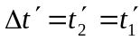
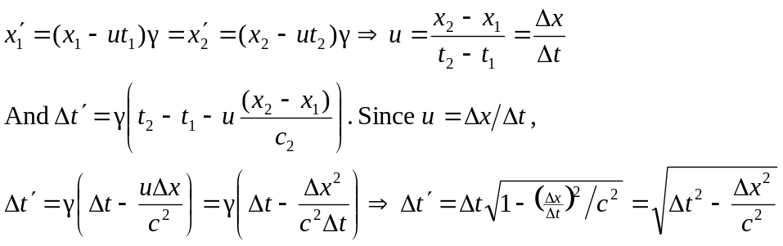

There’s no physical solution for 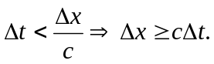
b) Simultaneously 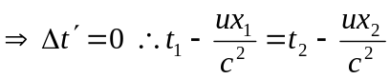
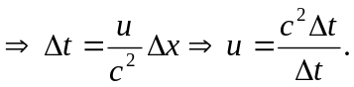
Also
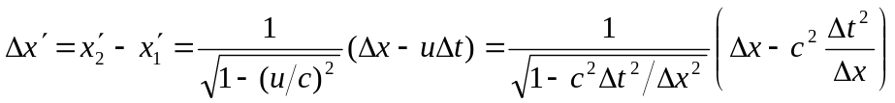
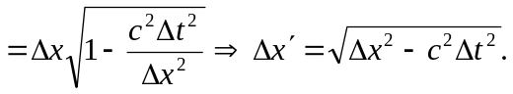
c) Part (b):

